**LINCOLN PARK WEST CONDOMINIUM ASSOCIATION**

**2020 LINCOLN PARK WEST, CHICAGO, IL**

**DOOR MODIFICATIONS**

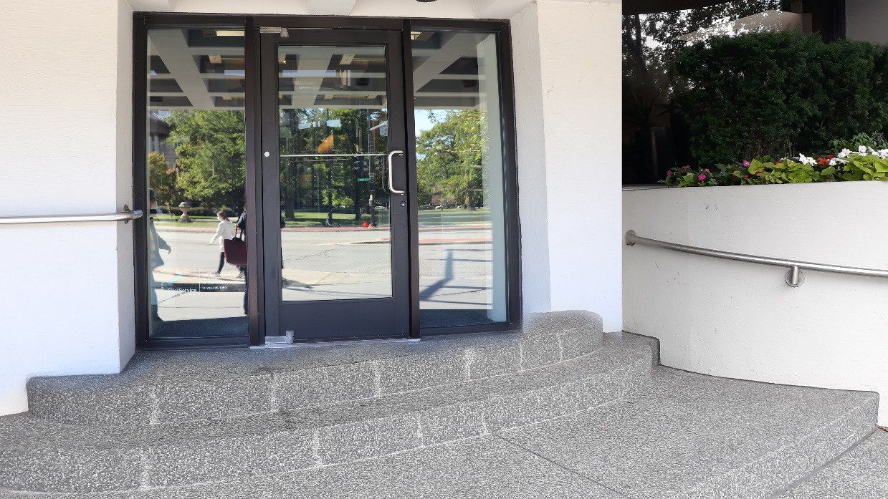

​FirstService Project Management was engaged by the Association Board at this Lincoln Park high-rise to manage a door modification project which included the removal and upgrading of the buildings existing door systems. The scope of work included:

* Daily Covid-19 screening, including temperature checks, face coverings, sanitizing stations, etc.
* Demo of door systems to be replaced
* Provide and install balanced door as listed in specifications
* Provide and install new storefront door and transom with electronic lock and automatic operator
* Remove and replace sealants as specified
* Ancillary electrical scope related to new balance and storefront doors
* Remove and replace interior perimeter sealant as specified

With cost savings generated by the project management team, over **$20,000**of remaining funds will now be used to fabricate and install a new rear entrance door.

*Professional, on task with keeping the project schedule and informative regarding project details.*

-Anonymous Board Member, 2020 LPW

**Reference:**

**America Moyeno**

**FSR Property Manager**

**America.Moyeno@fsresidential.com**