**LINCOLN PARK WEST CONDOMINIUM ASSOCIATION**

**2020 LINCOLN PARK WEST, CHICAGO, IL**

**GARAGE RENOVATION**

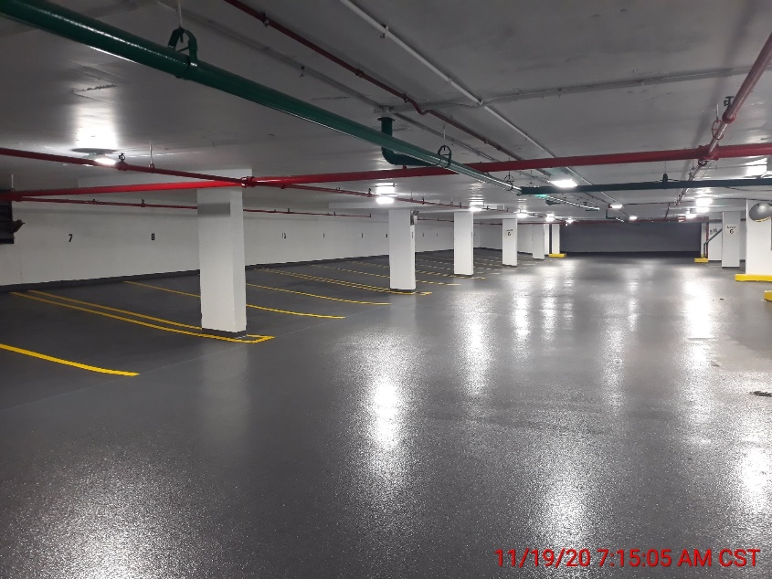

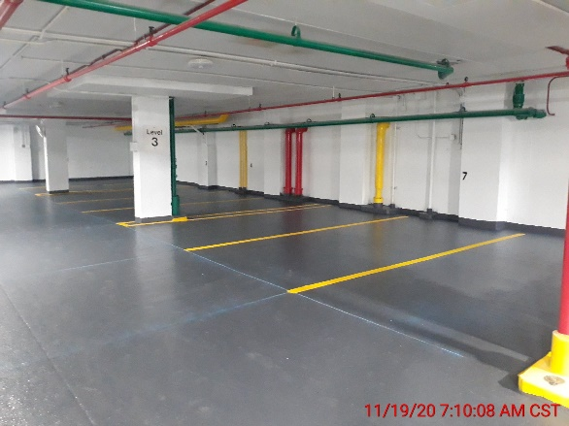

​FirstService Project Management was engaged by the Association Board at 2020 N Lincoln Park West to manage a critical garage repair project. The work ranged from simple crack repairs and tuckpointing to full scall membrane replacement and painting of the entire interior and exterior of the garage. The scope of work included:

* Remove & replace 100% of existing light fixtures with high efficacy, motion sensitive, LED fixtures.
* Exterior sealant replacement
* Rout & seal all significant cracks in need of being pretreated prior to membrane installation
* Install new waterproofing membrane system
* Remove all garage wheel stops and replace with new concrete wheel stops
* Apply highly reflective garage coating at walls, ceilings, and columns
* Install new line striping to match existing layout
* Clean, prepare, and paint all exposed surfaces at all parking levels within the garage
* At the exterior walls of the above ground garage, prepare, prime as necessary, and paint new and existing concrete on all garage elevations as specified
* Remove/dispose of all existing drain bodies and install new drain assemblies
* CMU wall rebuild- remove/replace deteriorated concrete masonry
* Miscellaneous grinding and tuckpointing of mortar joints throughout garage stairwell

With cost savings generated by the project management team, additional building repairs were added to the scope and over **$150,000** was returned to the Association.

*Professional, on task with keeping the project schedule and informative regarding project details.*

-Anonymous Board Member, 2020 LPW

**Reference:**

**America Moyeno**

**FSR Property Manager**

**America.Moyeno@fsresidential.com**