**LINCOLN PARK WEST CONDOMINIUM ASSOCIATION**

**2020 LINCOLN PARK WEST, CHICAGO, IL**

**DOMESTIC WATER LINE REPAIRS**

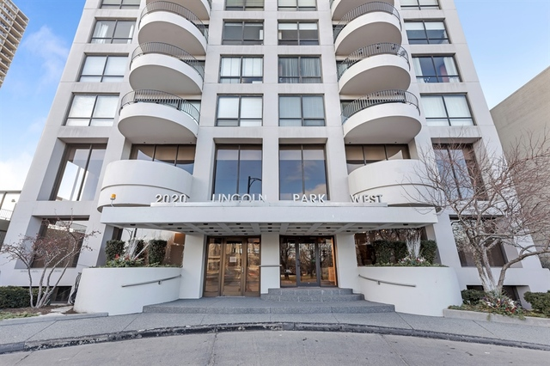

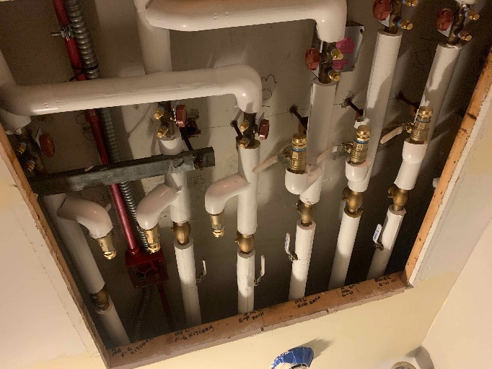

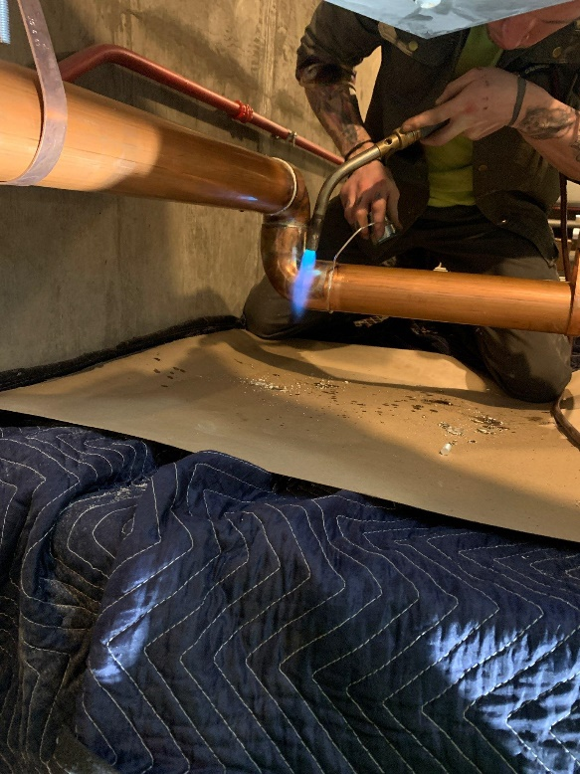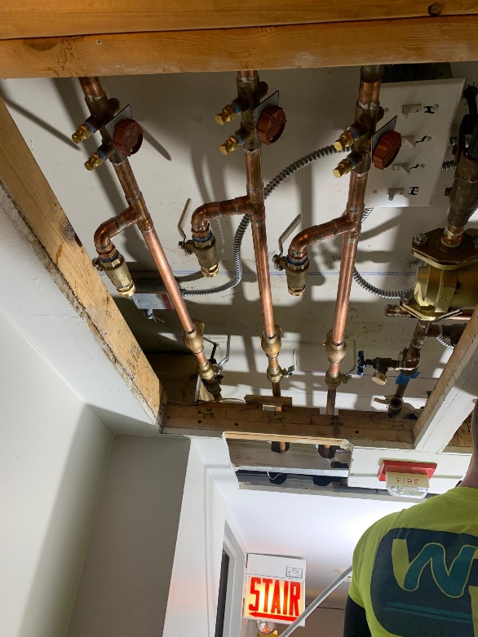

​FSPM successfully managed this domestic water line repair project where this property was experiencing serious issues due to leaking isolation valves. Timing was critical, and with FSPM's oversight, contractors were able to run a new return header pipe to connect to new isolation valves without removing the main parts of the mezzanine ceiling.

Asbestos was found on the cold-water line pipes and was abated prior to the start of this project.

​

Other portions of this scope included the removal of galvanized steel on the 39th and 40th floors, additional installation of fiberglass insulation and the removal and replacement of a number of mixing valves.

​

Because of FSPM's diligence, this project came in **$54,000 under budget**, which was returned to the Association.

**Reference:**

**America Moyeno**

**FSR Property Manager**

**America.Moyeno@fsresidential.com**

*Professional, on task with keeping the project schedule and informative regarding project details.*

-Anonymous Board Member, 2020 LPW